**Dollmart Toys Stores**

**Data warehouse Dimension Model Design**

1. High Level Dimension Model

**Orders**

Grain = 1 row per order detail line

**Figure:** Dollmart high-level orders dimensional model

1. Detailed Dimensional Model

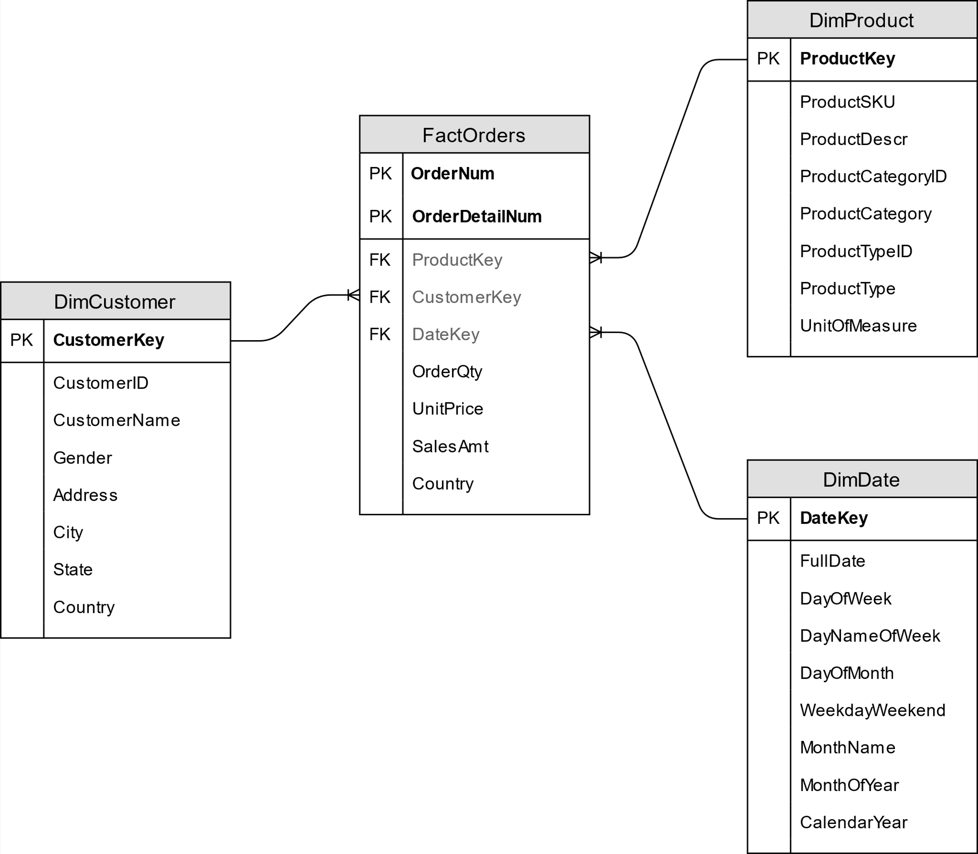

**Figure:** Dollmart detailed orders dimensional model